GRADE 7 ACCELERATED · UNIT 2 · LESSON 5
Rational and Irrational Numbers on the Number Line
Teacher's Edition
Standard and Targets
MA.8.NSO.1.2 Plot, order and compare rational and irrational numbers, represented in various forms.
Boundary Not the expectation to work with e. The expectation is to plot, order and compare square roots and cube roots. Use the symbols <, > and =.
Learning targets I can decide whether a number is rational. I can compare two numbers in different forms. I can order a set and plot it on a number line.
Essential questions How do you compare numbers written in different forms? What changes when the numbers are negative?
Building on Lesson 4's estimating, and MA.7.NSO.1.2 from Unit 1 — rewriting rational numbers in equivalent forms, which is what makes the conversion step possible.
Working toward MA.8.NSO.1.7, order of operations with radicals, and MA.912.NSO.1.4 in high school.
Where this sits in the course MA.8.NSO.1.2 is reported under Number Sense and Operations and Probability, 22–28% of the exam. There is no new procedure today — the lesson is Lesson 4's estimating applied to several numbers at once, plus one genuinely new idea about negatives.
Materials Whiteboards and markers. Calculators are open today; the estimating was taught yesterday and the work here is comparison. Worksheet 7A.02.05. No cards to cut — see below.
Lesson at a Glance
Windy Hill periods run 53 minutes.
Segment | Slides | Time
Settle in; post the learning target | 1 | 1 min
Warm-Up: same and different | 2 | 4 min
Notes I–III: one place on the line, decimals first, further left is smaller | 3–5 | 11 min
Example 1: four numbers, least to greatest | 6–9 | 9 min
Example 2: Marisol's work | 10–12 | 5 min
Whiteboards: 9 questions, each with its reveal | 13–30 | 18 min
IXL — start today's skills | 31 | 5 min
Total |  | 53 min

Where the lesson lives: Notes III (slide 5) and Example 2 (slides 10–12). Both are about negatives, and between them they are the only genuinely new content in the lesson.
Read this before you plan the day. Math Nation's component times total 40 to 50 minutes before any worksheet. The bigger problem is shape, not length: their 2.5.4 is a whole-class activity in which cards are handed out, students walk to a “rational” or “irrational” side of the room, split into groups by range, and order and plot together. That is a fifteen-minute group activity and it is the spine of their lesson.
No partner or group work anywhere in this lesson. Four printed instances plus the Which One Doesn't Belong routine, plus the 2.5.4 Activity described above. The Activity's mathematics is preserved: its sorting step is Notes I and worksheet question 1, its ordering step is Examples 1 and 2, and its plotting step is worksheet questions 8 and 9. Nothing is cut except the walking. There are no cards to print and no signs to make.
Vocabulary

rational number — a number that can be written as a ratio of two integers
irrational number — a number that cannot be written as a ratio of two integers
real numbers — the rationals and the irrationals together — everything on the number line
order — to arrange from least to greatest, or from greatest to least
A note on the glossary. Math Nation lists no key terms and no additional terms for this lesson. The four above are the ones the worksheet uses. “Real numbers” is added because it is the word for the whole set students are now plotting, and the assessment uses it.
Slide-by-Slide Teaching Notes
Slide 1. Rational and Irrational Numbers on the Number Line 1 min
- Post the learning target.
- Yesterday was estimating one root at a time.
- Today is several numbers at once, in different forms, and the new idea is what happens when they are negative.
Slide 2. Warm-Up 4 min
- TYPE: Same and different.
- INDEPENDENT.
- Expect: same — both irrational, both between 2 and 5 in size, neither radicand is a perfect power.
- Different — sign, index, and the value.
- Do not accept 'one has a three' without 'and that changes what the root means'.
- This is the discrimination the ordering questions need.
- OFF THE SLIDE, YOURS TO SAY: Both are irrational. One is negative, and one has a 3 in the notch.
Slide 3. Notes: I. Every real number has exactly one place on the line 3 min
- Students copy the two lines.
- The picture does the work: put √2, −π, 3/4 and 5 on one line and let them see four different-looking things as four points.
- Do not name density formally; the sentence in the panel is enough and it is what makes 'between' questions answerable.
- OFF THE SLIDE, YOURS TO SAY: A number line has no gaps. Between any two numbers there is another.
Slide 4. Notes: II. Turn every number into a decimal first 4 min
- Students copy verbatim.
- The third line is the one they skip: √49 is 7, not 'about 7', and writing 7.00 beside it is what stops them treating every radical as an approximation.
- Two decimal places is a deliberate cap — three invites arithmetic errors that have nothing to do with this benchmark.
- OFF THE SLIDE, YOURS TO SAY: Never compare a root with a decimal by eye. Convert, then compare.
Slide 5. Notes: III. With negatives, further left is smaller 4 min
- THE NEW IDEA IN THIS LESSON.
- Everything before today was ordering positives.
- Draw −5 and −2 and ask which is further right before you ask which is greater — the picture settles it and the rule follows from the picture rather than being asserted.
- Whiteboard questions 1, 2, 3, 5 and 6 are all this.
- Question 4 is the exception on purpose: it is the same numbers as question 3 with both signs positive, so the class can see the rule stop applying.
- OFF THE SLIDE, YOURS TO SAY: The number that looks bigger is the smaller one, once it is negative.
Slide 6. Example 1 2 of the 9 min
- SPOKEN ONLY.
- No pencils.
- Answers: 1) √3 and π are irrational; −11/5 is a fraction of integers and −∛50 is irrational too, so three of the four — expect them to miss the last one. 2) −∛50, because it is the only one below −3. 3) Usually −∛50 against −11/5.
- That is the pair the next slide resolves.
Slide 7. Example 1 3 of the 9 min
- They write the four decimals on whiteboards, not the order.
- Holding the ordering back one step is the point: a student who orders first and converts second is guessing, and this slide takes that option away.
Slide 8. Example 1 2 of the 9 min
- ANSWERS: √3 ≈ 1.73, −11/5 = −2.20 exactly, π ≈ 3.14, −∛50 ≈ −3.68. Only −11/5 is exact; say so and write the equals sign differently. For −∛50: 3³ = 27 and 4³ = 64, so it is between 3 and 4, and 50 is nearer 64 — but 3.5³ = 42.875, so it is past 3.5. That is the cube-root check from Lesson 4.
- OFF THE SLIDE, YOURS TO SAY: −∛50 ≈ −3.68 is the one to slow down on: 50 is between the cubes 27 and 64.
Slide 9. Example 1 2 of the 9 min
- The order is −∛50, −11/5, √3, π.
- Plot all four on the board line yourself — the slide deliberately does not, so the plotting is done in front of them rather than read off.
- The panel is Notes III doing work: −∛50 has the larger magnitude and sits further left, which is the thing they will get wrong on the worksheet if they ordered by the numbers inside the radicals.
- OFF THE SLIDE, YOURS TO SAY: Two negatives first — the bigger root sits further left.
Slide 10. Example 2 2 of the 5 min
- Do not let anyone say 'she is wrong' and stop.
- Ask what she did that was right first — 50 > 49 is true, and √50 > √49 is true.
- The error is in the last step only, and finding exactly where is the skill.
Slide 11. Example 2 2 of the 5 min
- This is the slide that separates 'wrong answer' from 'wrong at a named step'.
- Two true statements and one false one.
- A student who cannot point at line 3 has not understood Notes III, whatever they wrote on Example 1.
- OFF THE SLIDE, YOURS TO SAY: Everything before the last line is correct. That is what makes it convincing.
Slide 12. Example 2 1 of the 5 min
- COLOR: the left-hand number is blue and the right-hand number is orange, on both lines, so the decimal under each one is visibly its decimal. No formula on this slide, so color names objects, not slots. −7.071 is further left than −7.000, so −√50 is the smaller. Marisol's sentence becomes true if you delete both minus signs.
Slide 13. Whiteboards · Question 1 of 9 — ask about 20 seconds of thinking
- Boards down until the cue, all up together, scan the back row first, and question a blank board before a wrong one.
- Do not reveal until every board is up.
Slide 14. Whiteboards · Question 1 of 9 — reveal about 1 minute with the discussion
- √16 is exactly 4, so both sides are −4.000.
- The only equality in the set, and it is first on purpose: a root that comes out even is not an estimate.
- COLOR: left-hand number blue, right-hand number orange, and each decimal underneath carries its own color. No formula on the slide, so the color names which number, not which slot.
Slide 15. Whiteboards · Question 2 of 9 — ask about 20 seconds of thinking
- Boards down until the cue, all up together, scan the back row first, and question a blank board before a wrong one.
- Do not reveal until every board is up.
Slide 16. Whiteboards · Question 2 of 9 — reveal about 1 minute with the discussion
- One digit inside the radical, and the equality is gone. −4.123 is further left than −4.000.
- Expect students who answered = on question 1 to answer = again here.
- COLOR: left-hand number blue, right-hand number orange, and each decimal underneath carries its own color. No formula on the slide, so the color names which number, not which slot.
Slide 17. Whiteboards · Question 3 of 9 — ask about 20 seconds of thinking
- Boards down until the cue, all up together, scan the back row first, and question a blank board before a wrong one.
- Do not reveal until every board is up.
Slide 18. Whiteboards · Question 3 of 9 — reveal about 1 minute with the discussion
- Same left-hand number, and now the right-hand one has a decimal place.
- Estimating √17 as 'about 4.1' is no longer good enough — you need the second place.
- The board to look for says =.
- COLOR: left-hand number blue, right-hand number orange, and each decimal underneath carries its own color. No formula on the slide, so the color names which number, not which slot.
Slide 19. Whiteboards · Question 4 of 9 — ask about 20 seconds of thinking
- Boards down until the cue, all up together, scan the back row first, and question a blank board before a wrong one.
- Do not reveal until every board is up.
Slide 20. Whiteboards · Question 4 of 9 — reveal about 1 minute with the discussion
- THE ONE THAT EARNS ITS PLACE.
- Identical numbers to question 3, both signs flipped, and the answer flips with them.
- If a student carries < across from the previous slide, the sign is the thing they are not seeing.
- COLOR: left-hand number blue, right-hand number orange, and each decimal underneath carries its own color. No formula on the slide, so the color names which number, not which slot.
Slide 21. Whiteboards · Question 5 of 9 — ask about 20 seconds of thinking
- Boards down until the cue, all up together, scan the back row first, and question a blank board before a wrong one.
- Do not reveal until every board is up.
Slide 22. Whiteboards · Question 5 of 9 — reveal about 1 minute with the discussion
- Back to two negatives after question 4's positive contrast, and against question 3 the index changes from 2 to 3.
- The comparison value has to move with it — −4.1 to −2.6 — because a cube root of 17 is nowhere near a square root of 17. ∛17 ≈ 2.571, so −2.571 sits to the RIGHT of −2.6 and is greater.
- Two negatives, and the smaller-looking one wins.
- COLOR: left-hand number blue, right-hand number orange, and each decimal underneath carries its own color. No formula on the slide, so the color names which number, not which slot.
Slide 23. Whiteboards · Question 6 of 9 — ask about 20 seconds of thinking
- Boards down until the cue, all up together, scan the back row first, and question a blank board before a wrong one.
- Do not reveal until every board is up.
Slide 24. Whiteboards · Question 6 of 9 — reveal about 1 minute with the discussion
- Same left-hand number as question 5; the comparison value moves from −2.6 to −2.5, across the true value, and the answer flips.
- A student who answered question 5 by feel rather than by computing cannot get both right.
- COLOR: left-hand number blue, right-hand number orange, and each decimal underneath carries its own color. No formula on the slide, so the color names which number, not which slot.
Slide 25. Whiteboards · Question 7 of 9 — ask about 20 seconds of thinking
- Boards down until the cue, all up together, scan the back row first, and question a blank board before a wrong one.
- Do not reveal until every board is up.
Slide 26. Whiteboards · Question 7 of 9 — reveal about 1 minute with the discussion
- One feature changed: the radicand is much larger, and the comparison number is a whole one. −√50 is −7.071, which sits to the LEFT of −7.000, so it is less.
- THE BOARD TO LOOK FOR SAYS >, and the reasoning behind it is audible: 50 is bigger than 49, so √50 is bigger than 7, so −√50 must be bigger too.
- The first two steps are right and the third is where it breaks — under a minus sign, bigger goes further left.
- This is questions 2 and 3 at a new scale, and a student who has the idea rather than the two memorized answers will get it.
- COLOR: left-hand number blue, right-hand number orange, and each decimal underneath carries its own color. No formula on the slide, so the color names which number, not which slot.
Slide 27. Whiteboards · Question 8 of 9 — ask about 20 seconds of thinking
- Boards down until the cue, all up together, scan the back row first, and question a blank board before a wrong one.
- Do not reveal until every board is up.
Slide 28. Whiteboards · Question 8 of 9 — reveal about 1 minute with the discussion
- One feature changed: no radical on either side, and both numbers are positive for the first time since question 4. π is 3.14159…, and 3.14 is 3.14000 — π is GREATER.
- THE BOARD TO LOOK FOR SAYS =, and it is the most forgivable wrong answer in the unit: they have been told to use 3.14 for π since grade 6, and the reference sheet says the Grade 8 FAST hands them 3.14 to compute with.
- Hand it to them and say the precise thing — 3.14 is what you are given to CALCULATE with, and it is not π.
- Lining the two decimals up to the same number of places is what makes it visible, which is what every reveal in this round has been doing.
- COLOR: left-hand number blue, right-hand number orange, and each decimal underneath carries its own color. No formula on the slide, so the color names which number, not which slot.
Slide 29. Whiteboards · Question 9 of 9 — ask about 90 seconds of writing
- Boards down until the cue, all up together.
- This one is written, so give it the time — a board going up early here is a board with one word on it.
Slide 30. Whiteboards · Question 9 of 9 — reveal about 2 minutes with the closing discussion
- WRITTEN WORK, and the only question in the round that asks for it.
- With the worksheet gone this is the only place in the period the habit gets built, and IXL takes an answer without ever seeing the work.
- ANSWER: no. √17 = 4.123…, so −√17 = −4.123…, which is to the left of −4 and therefore less.
- HER FIRST STEP IS CORRECT AND THE QUESTION ASKS FOR THAT — 17 really is greater than 16, so √17 really is greater than √16, so √17 > 4.
- Everything up to the minus sign is sound.
- What she has done is carry an ordering through a negation without turning it over, which is the same move that reverses an inequality sign when you divide by a negative — and they met that in Unit 1.
- A number line settles it faster than any rule: put −4 and −4.123 on it and look at which is further left.
Slide 31. IXL 5 min
- IXL.
- The skills are assigned in Google Classroom, not named here, and they are deliberately not ours -- Croix: "The students need questions that aren't exclusively mine.
- Makes them think." Circulate.
- The thing to watch for is a student answering in the box with no paper in front of them: IXL takes an answer and never sees the work, so this is the one part of the period where the habit can quietly lapse.
Worksheet 7A.02.05 — Answer Key
1. the sort | Rational: 0.125, −8, −√49, ∛−8, −13/3 Irrational: −√12, −2π  The two traps are −√49 = −7 and ∛−8 = −2. −13/3 is printed as a ratio already.
2. ∛30 vs 7/2 | <  3.107 and 3.5.
3. −2√49 vs −14.123… | >  −2√49 = −14, and −14.123… is further left. The greater one is the one nearer zero.
4. π² + 1 vs 3π | >  10.870 and 9.425.
5. −√64 vs ∛−64 | <  −8 and −4.
6. √121 vs 11 | =  The only equality on the sheet. A student who never writes = has not checked this row.
7. 29/6 vs 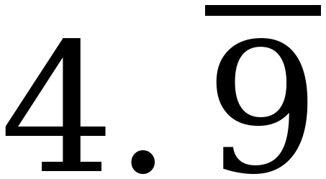 | <  4.833 and 5. Four point nine repeating is exactly 5 — worth one sentence out loud.
8. order and plot | 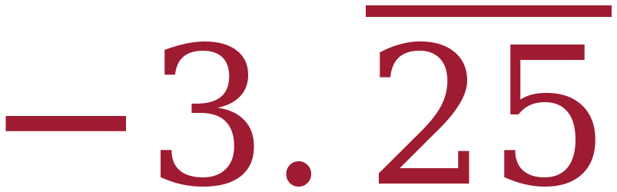 , −7/8 , ½π , 2½ , ∛60 , √22  Decimals: −3.2525; −0.875; 1.571; 2.5; 3.915; 4.690. Five sit on or beside a half-unit mark; −3.25 repeating sits square between −3.5 and −3, which is worth pointing at.
9. order and plot | −√54 , −2π , ∛−32 , 19/3 , 7.4  Decimals: −7.348; −6.283; −3.175; 6.333; 7.4. A student who puts −2π first has ordered by size instead of by position.
10. which is greater | −2π. It is −6.28 against −7, and −6.28 sits further right.  The point needs the diagnosis too: the other answer compares 7 against 6.28 and drops the sign.

Questions 8 and 9 are the ones to circulate for. Look for decimals written beside the numbers. A student who has not converted is guessing, and it costs nothing to catch it while they are still in the room.
Question 6 is worth a whole-class beat. It is the only equality on the sheet. Ask how many students wrote = at least once — the ones who did not have been assuming the answer is always < or >.
Additional Practice 7A.02.05 — Answer Key
1. the sort | Rational: 0.4, −6, −√36, ∛−27, −11/3 Irrational: −√20, −⅔π  −√36 = −6 and ∛−27 = −3 are the traps.
2. ∛−56 vs −3¾ | <  −3.826 and −3.75.
3. π/2 − 3 vs −3 + ½π | =  The same expression written two ways. Both are −1.4292.
4. √20 vs 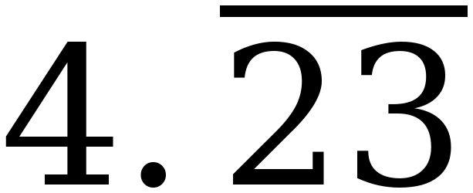 | >  4.472 and 4.2323.
5. −∛125 vs −√100 | >  −5 and −10. The negatives trap.
6. 123/15 vs 8.25 | <  8.2 and 8.25.
7. 4√35 vs 23.12122… | >  23.664 and 23.121.
8. order and plot | −√15 , −⅔π , 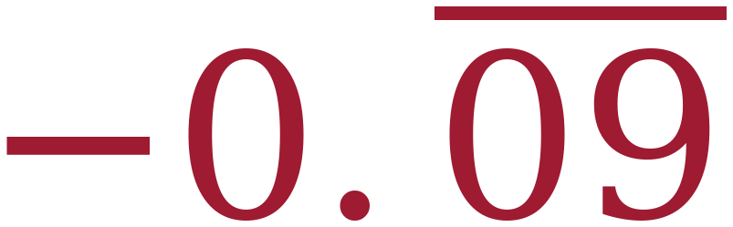 , 65/16 , √45  Decimals: −3.873; −2.094; −0.0909…; 4.0625; 6.708. −0.09 repeating is −1/11, the closest of the five to zero.
9. order and plot | −98/11 , π² − 9 , −∛−88 , 6½ , √63  Decimals: −8.909; 0.870; 4.448; 6.5; 7.937. The third is a double negative — ∛−88 ≈ −4.448, so its opposite is positive.
10. which is greater | −⅔π. It is −2.09 against −6.  Same diagnosis required as on the worksheet.

This sheet is optional. Post it to Google Classroom. It is not assigned and it is not collected.
Changes from the Math Nation Lesson
- The homework's six comparisons had the same answer six times. Every one of their questions 1 to 6 works out to <, so a student who wrote < six times without reading scored 6/6. Their own practice sheet for the same lesson is built properly — its answers run < = > > < > — so the worksheet was rebuilt to match that design. Its answers now run < > > < = <, with one genuine equality.
- Two orderings were retuned so they can actually be plotted. Their question 7 asks students to order ½π = 1.5708 against 1⅗ = 1.6000 — a gap of 0.029, which no estimation method reaches and no student can show on a number line. Their question 9 pairs 19/3 = 6.3333 with 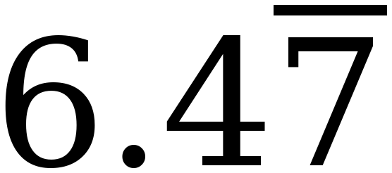 = 6.4778. Both sets keep their shape and their difficulty; the two crowded values were replaced with 2½ and 7.4 so that no two points on either line sit closer than three quarters of a unit.
- One piece of odd notation was tidied. Their practice sheet writes 98/−11, with the negative in the denominator; it is now −98/11, on additional practice question 9. Their homework also wrote −5 15/30 for −5½, but that item was one of the six comparisons rebuilt above, so the number is not on these sheets at all and there was nothing left to tidy.
- The 2.5.4 Activity is rebuilt as individual work. Cards, room signs and groups are gone; the mathematics is now Notes I, Examples 1 and 2, and worksheet questions 1, 8 and 9. Nothing was cut except the walking.
- Every other partner instance is replaced — four printed prompts plus the Which One Doesn't Belong routine.
- The warm-up was replaced. Math Nation's Which One Doesn't Belong — 3.14, 22/7, π and 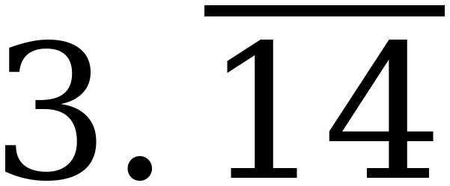 — is a good opener, but it is a discussion routine and its four defensible answers need a room talking to each other. Slide 2 is a same-and-different on √17 and −∛17 instead: written, individual, and pointed straight at this lesson's question, which is where a number goes on the line rather than which one is odd.
- The wrap-up was replaced. Theirs asks for “a summary of what you learned,” keyed “answers will vary.” The Ticket Out the Door asks three questions with right answers, and the second one is the negatives distinction.
- Nothing ELSE in the mathematics was changed — beyond the rebuilt comparison set and the two retuned orderings named above. Every comparison and every ordering on their sheets was checked and every one of them was correct; what was wrong with the six comparisons was the design, not the answers.

